Subject bp

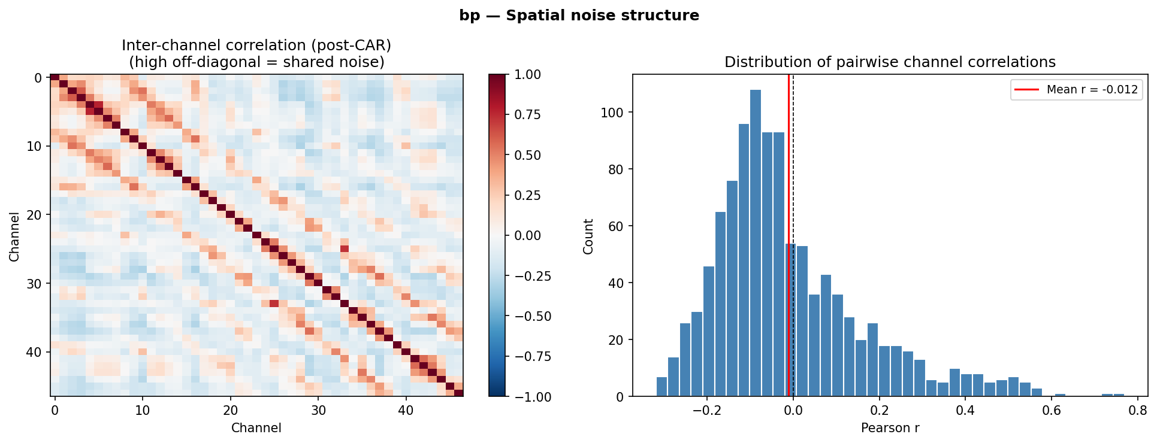

• Inter-channel correlation matrix (left) computed across all 47 electrodes after CAR preprocessing
• Majority of off-diagonal entries are near-zero or slightly negative, confirming CAR successfully removed the global common-mode signal shared across the electrode grid
• A localised cluster of elevated positive correlations visible among channels 0–12 (r up to 0.7), possibly reflecting spatial overlap between physically adjacent electrodes- due to activation by the task?
• Right panel shows the full pairwise Pearson r distribution: approximately zero-centred (mean r = −0.012) with a rightward skew driven by the residual local cluster
• Slight negative bias (mean r = −0.012) is a known mathematical consequence of CAR — the constraint that CAR-referenced channels sum to zero forces mean off-diagonal covariance toward zero
• Residual inter-electrode correlation structure -> redundancy-aware channel selection (mRMR), however inter-electrode correlation is not that high after CAR
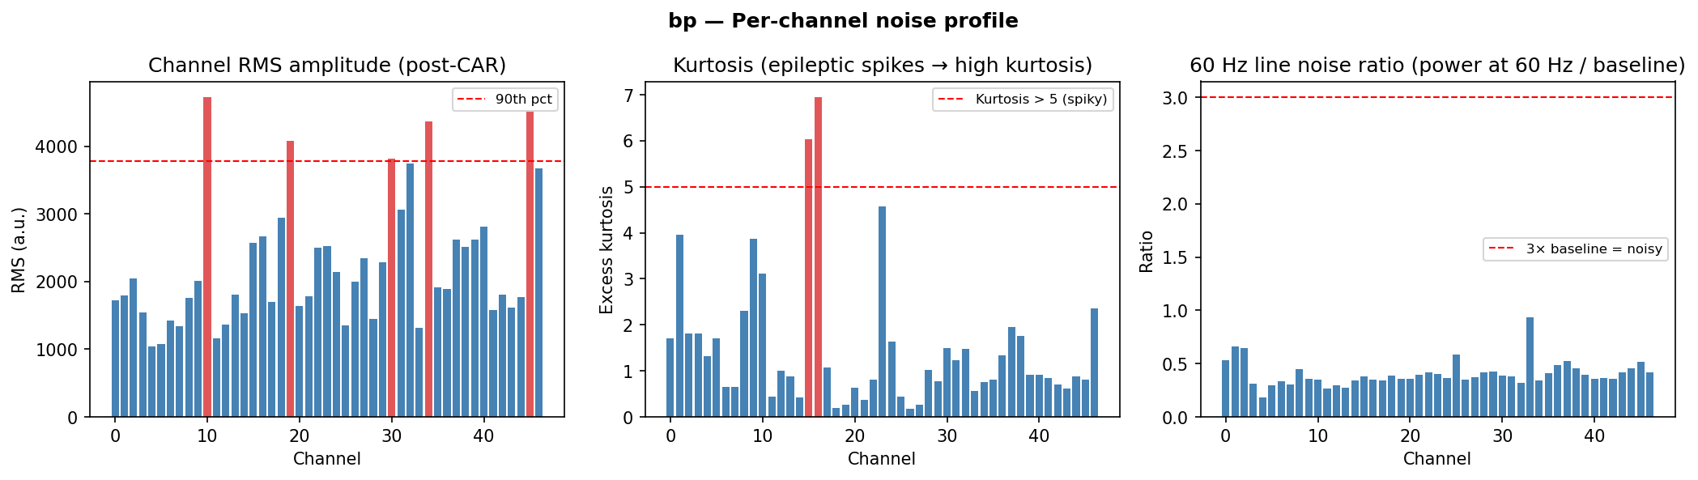
Per-channel noise profile for subject bp (post-CAR).
- Three complementary noise metrics should have been computed per channel to identify problematic electrodes prior to classification pipeline entry
- Left — Channel RMS amplitude: five channels exceed the 90th percentile threshold (channels 10, 18, 30, 34, 46, shown in red); elevated RMS alone is ambiguous — could reflect strong genuine neural signal or poor electrode contact, requiring visual inspection of raw time series to distinguish
- Middle — Excess kurtosis: channels 15 and 16 dramatically exceed the kurtosis > 5 threshold (kurtosis ≈ 6–7), indicative of intermittent large-amplitude epileptic spike activity arising from the patient's seizure focus; channel 23 shows borderline elevation (~4.7) and warrants monitoring;
- Epileptic spikes are pathological discharges unrelated to the motor task and would introduce non-stationary variance into covariance estimates, distorting Riemannian distances and potentially creating spurious discriminative signal if spike timing correlates with trial structure
- Right — 60 Hz line noise ratio: all channels fall well below the 3× baseline threshold; 60 Hz harmonics at 120 Hz and 180 Hz are not present at problematic levels, so notch filtering is unnecessary for this subject
- Channels 15 and 16 are flagged for exclusion from all subsequent pipeline stages; high-RMS channels require raw time-series inspection before a keep/exclude decision is made
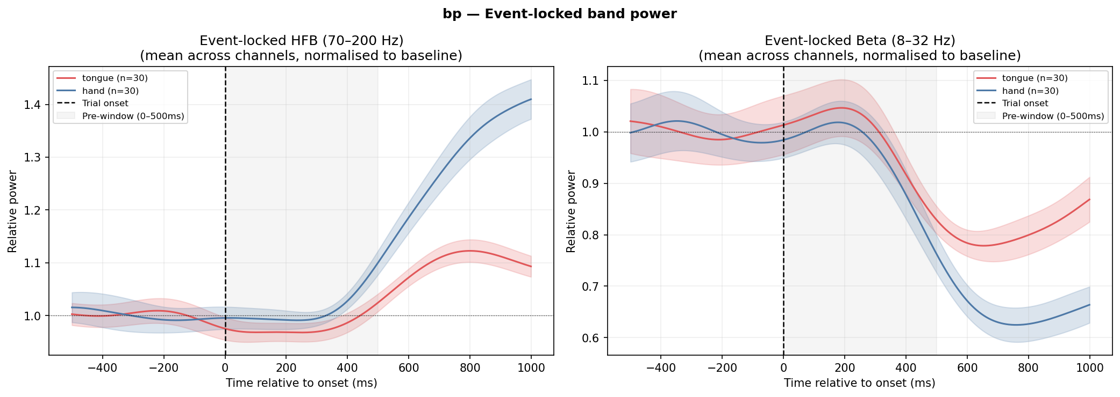
Event-locked band power for subject bp. Both HFB (70–200 Hz) and beta (8–32 Hz) show clear movement-locked responses time-locked to trial onset — HFB increases post-movement while beta suppresses, with hand eliciting a stronger response than tongue

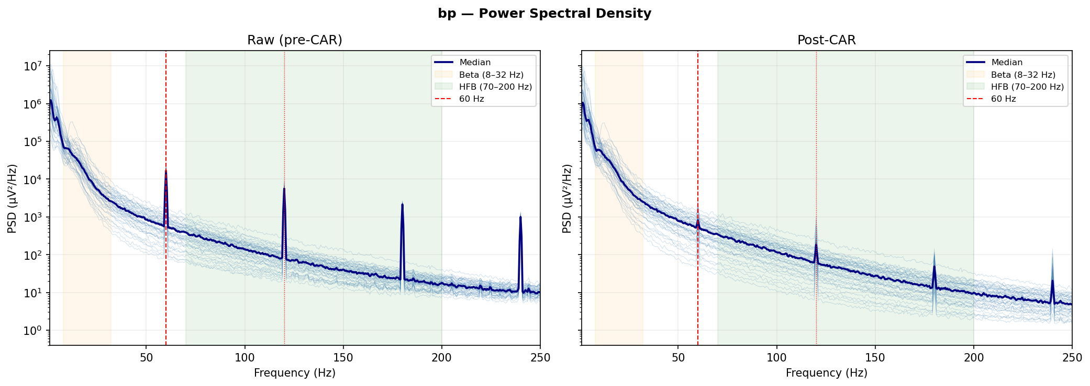
Power spectral density pre- and post-CAR for subject bp, showing prominent line noise at 60 Hz and harmonics (120, 180, 240 Hz) in the raw signal; CAR substantially removes the 60 Hz fundamental via common-mode rejection but residual harmonics at 120 and 180 Hz survive into the HFB band (70–200 Hz), necessitating notch filtering at all harmonic frequencies prior to covariance estimation.
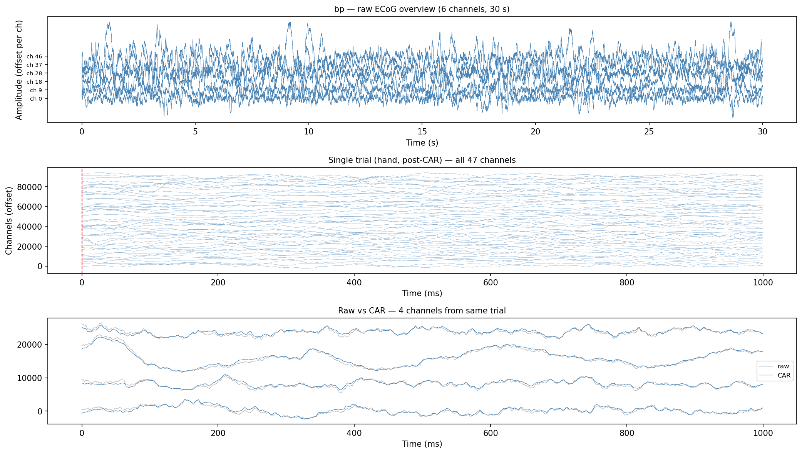
Raw ECoG time series inspection for subject bp.
- 30-second overview (top) shows continuous, physiologically plausible signal across 6 representative channels with no gross artifacts (flat lines, saturation, or step discontinuities), though slow low-frequency drifts are visible in some channels
- Single hand trial post-CAR across all 47 channels (middle) shows clean signal quality with no obvious single-trial artifacts across the 1000ms epoch window
- Raw vs CAR comparison (bottom) confirms CAR correction is modest for these channels, with the largest raw-CAR divergence occurring at movement onset (0–200ms);
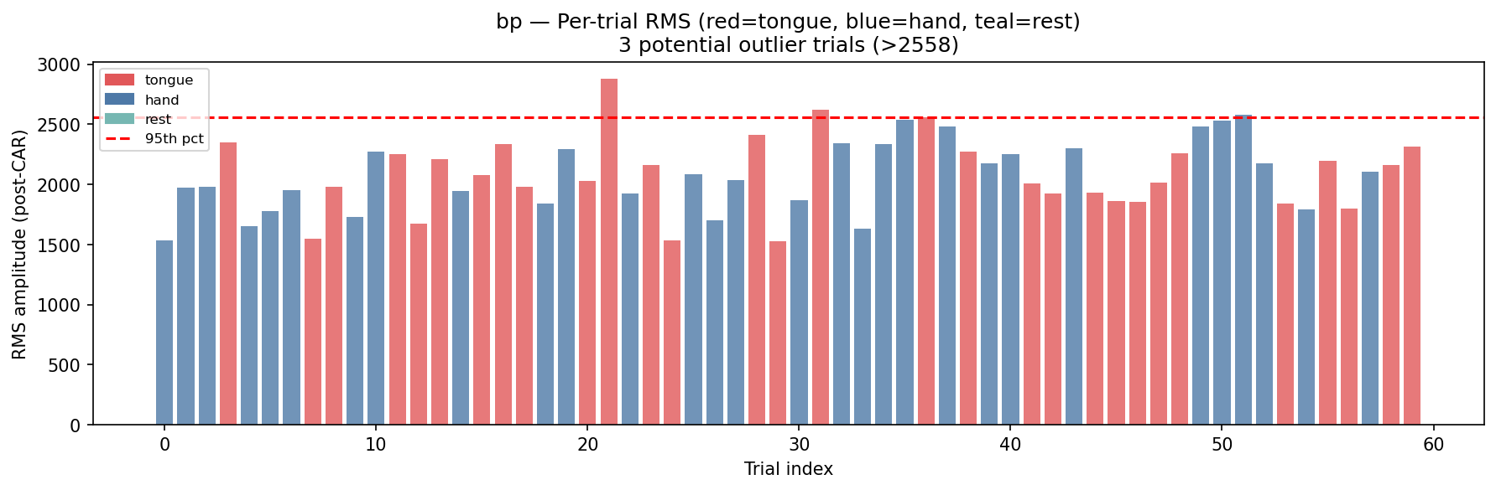
Per-trial RMS amplitude for subject bp, showing generally stable signal quality across the session with 3 trials exceeding the 95th percentile threshold (RMS > 2558) — two tongue trials (~21, ~31) and one hand trial (~52) — which should be flagged for exclusion prior to covariance estimation to prevent outlier trials from distorting the Riemannian mean during classifier training.
BETWEEN SUBJECT
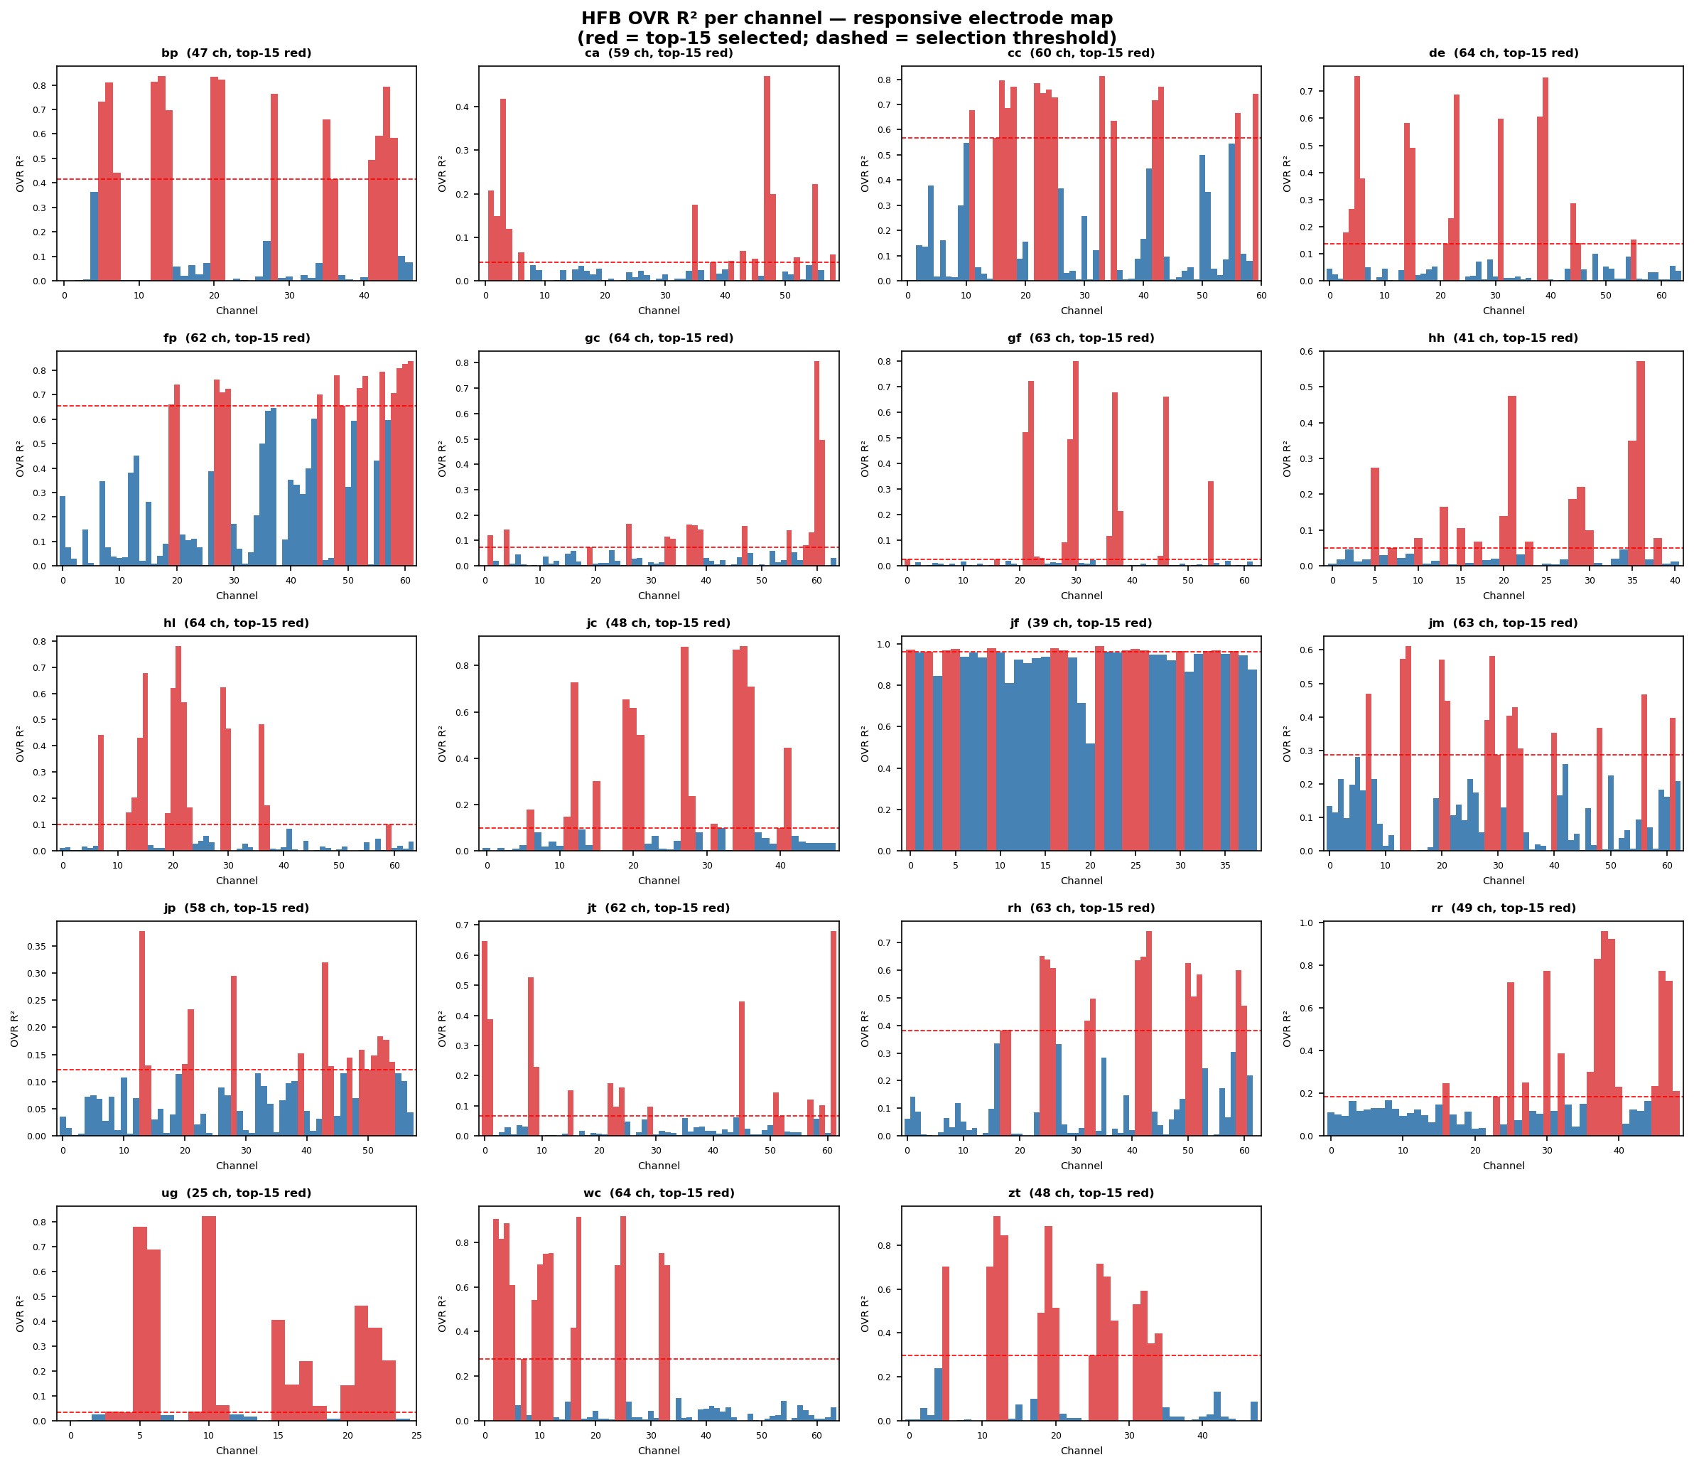
HFB OVR R² per channel for all subjects, revealing substantial inter-subject variability in motor cortex electrode responsiveness — ranging from strong, spatially concentrated discriminability (fp, ug, cc) through moderate responses (bp, hl, jk) to near-absent HFB discriminability (gc, gf, jp), with subject jf showing anomalously high R² (≈1.0) across nearly all channels that warrants investigation for potential data artifacts prior to inclusion in group analyses.
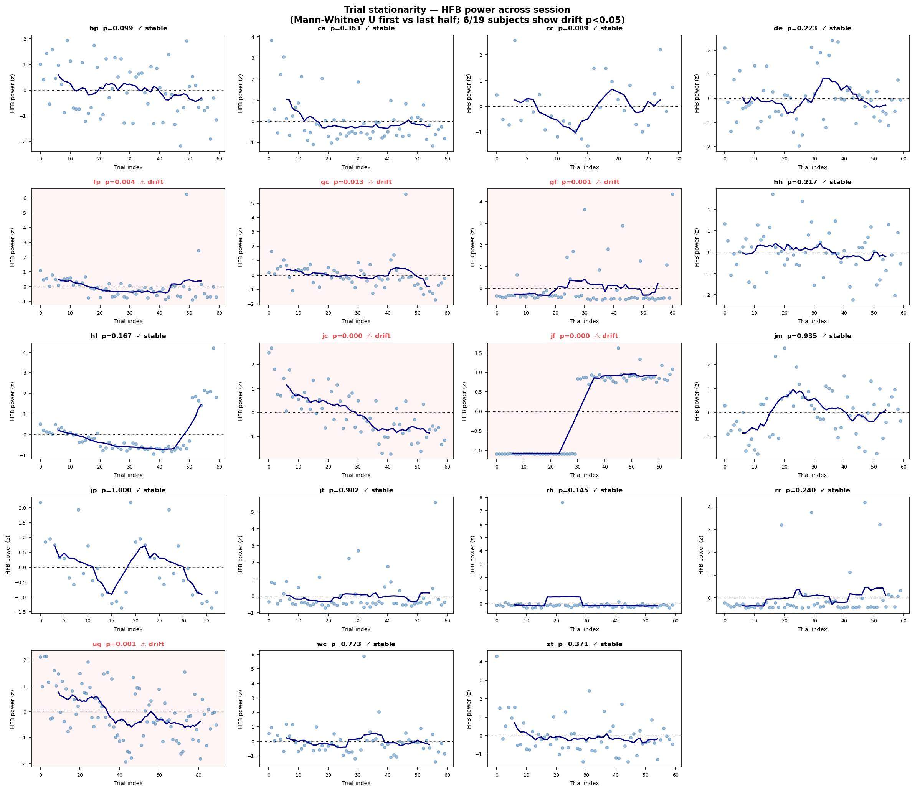
Trial stationarity of HFB power across session for all subjects — 6/19 subjects show significant drift (Mann-Whitney U, p<0.05), including gradual attenuation in fp (p=0.004), gc (p=0.013), gf (p=0.001), and ug (p=0.001), and discrete step changes in jc (p=0.000) and jf (p=0.000), the latter exhibiting a near-zero to high-power transition at trial ~30 that explains the anomalous R²≈1.0 observed in the responsive electrode map and confirms jf as an artifact-driven outlier requiring exclusion. Reject JF.

